 | 
Newsletter
November/December
  November  Canadian Rotary Tour  Friday 2nd November  Junior International Curling Competition  9th – 11th November 18  December  Area 13 Bonspiel Dennis Bowl  Saturday 1st December    Ultra-White Collar Boxing – Saturday 15th December  Ice Factor  Saturday 29th December  Ice Factor Skating Show – 29th December 18  SUMMER SPIEL  Inverness Ice Centre is looking at the possibility of holding a Summer Spiel towards the end of June 2019.  To register interest or submit entries please contact Keith Petrie by Wednesday 19th December.  keith.petrie@inverness-ice-centre.co.uk | Inverness Ice Centre is celebrating its 50th anniversary this year and as part of our celebrations these sessions are FREE:  Tuesday 6th November - 5.25pm - 6.45pm  Tuesday 13th November - 5.25pm - 6.45pm  Sessions are then as follows:  Tuesday 20th November - 5.25pm - 6.45pm  Tuesday 27th November - 5.25pm - 6.45pm  Tuesday 4th December - 5.25 - 6.45pm  Tuesday 11th December - 5.25 - 6.45pm  Adults - £5 per session  Juniors - £3.00 per session  To register please contact: highlandcurlingcoaches@gmail.com  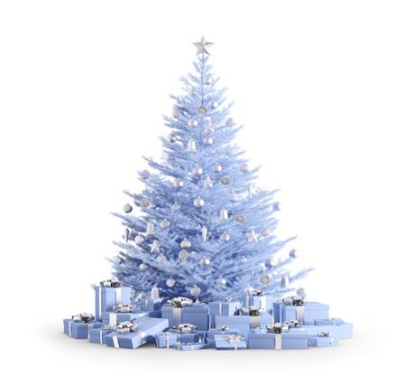  Christmas Gifts  Some ideas for stocking fillers or an unusual gift for that person who have everything this Christmas!  Family Skating Gift Voucher  £21.00  Curling Stone Handle Engraving  from just £99!  Or  Buy one & get one half price!
ICE FACTOR
Saturday 29th December
7.00pm
£6 for Adults
£3 for under 18's.
Inverness Ice Centre

Bonfire Night 2018
Monday 5th November
Please be aware there will be traffic restrictions in the surrounding area during this event.
If you are due to be here that night please pick up a Parking Pass from Keith as our car park will be monitored.

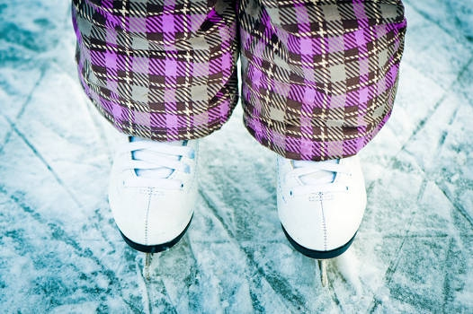  Public Ice Skating Timetable  For more sessions please visit our website    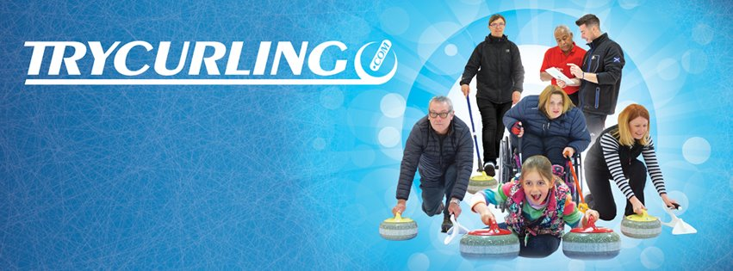  We would love to hear from you!  If you have any news or are holding any events and would like to share them with us please get in touch. We can share news and events on our website, facebook, twitter and our newsletter.  Email: carolineallan.iic@outlook.com |   7th Highland Wheelchair Curling Triples Competition  CONGRATULATIONS TEAM DONALDSON  (Pic L- R) - Owen Streeter, Ian Donaldson (skip) and David Hogg.  Runner-up Team Gault Jim Gault (skip), Gregor Ewan and Jim Sellar.  Third place - Team McGarry - Stephen McGarry (skip), Jeff Ward and Christine Warwick.  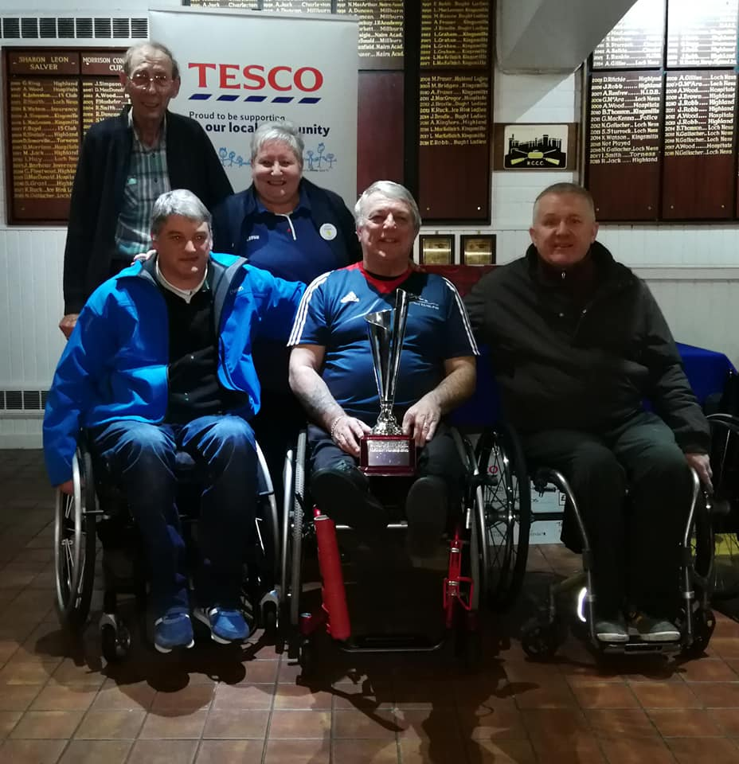
  Saturday 3rd November | 2pm – 4.30pm
  Sunday 4th November | 2pm – 4.30pm
  Sunday 11th November | 2pm – 4.30pm
  Sunday 19th November | 2pm – 4.30pm
  Sunday 25th November | 2pm – 4.30pm
  Sunday 2nd December | 2pm – 4.30pm
  Sunday 9th December | 2pm – 4.30pm
